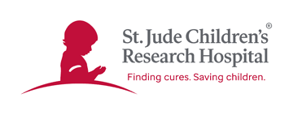

2022

Minden St. Jude Auction Sponsorship Invoice

PLEASE CHECK ONE:
$1,000 Silver ______
$1,500 Gold ______
$2,500 Platinum ______
DEADLINE FOR PRINTING: JANUARY 8, 2022
Please let us know by the above date if you wish to be included as a sponsor for the Minden St Jude Auction by one of the following:
Email of intent: MBrown1300@aol.com
Receipt of check mailed to:
St Jude Children’s Research Hospital
P.O. box 583
Minden, LA 71058
CONTACT INFORMATION:

Contact Name _________________________________________________________
Business Name (For Printing Purposes) _____________________________________
Mailing Address________________________________________________________
City__________________________________________________________________
Phone________________________________________________________________
Email Contact__________________________________________________________
Website______________________________________________________________
THANK YOU FOR SUPPORTING THE KIDS OF ST. JUDE!

Minden St. Jude Auction

P.O. BOX 583

MINDEN, LA 71058

318-371-1300

MINDENSTJUDE.COM

